# 2017 Observing Notes

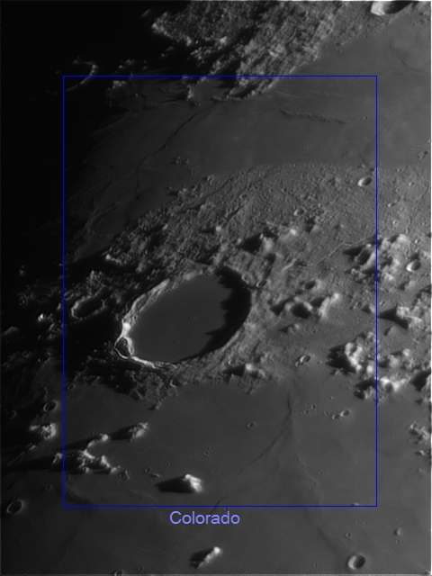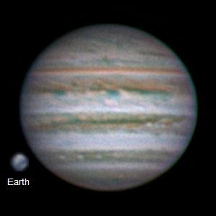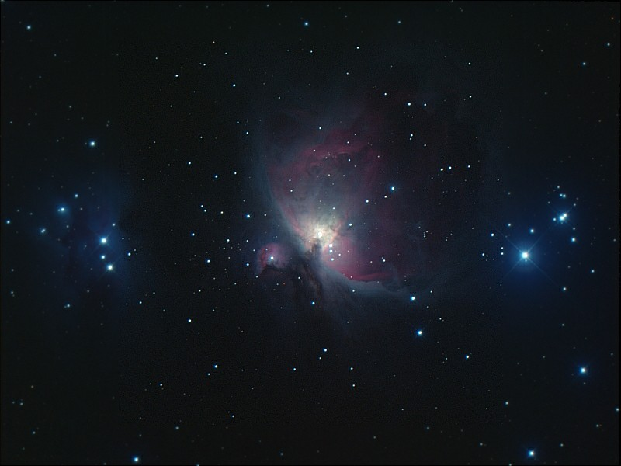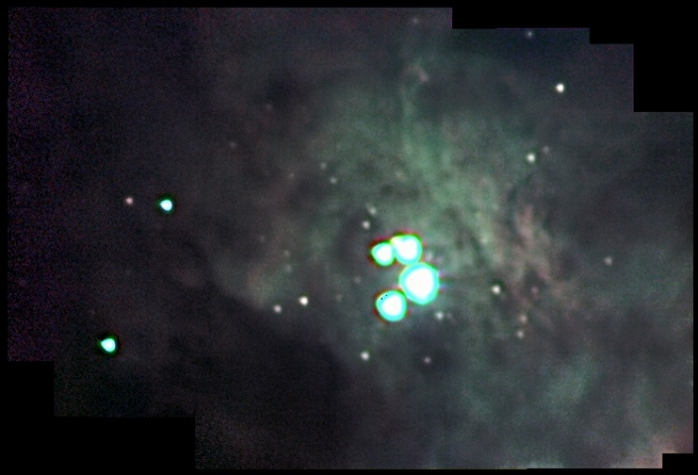

[2017 Observing Notes 1](#_Toc481912514)

[Year in Review 3](#_Toc481912515)

[January 4](#_Toc481912516)

[2017-Jan-17 (Jan-18 UT): M42 in 889nm CH4 4](#_Toc481912517)

[2017-Jan-18 (Jan-19 UT): M33 in 889nm CH4 and M42 in >685nm NIR and 889nm CH4 5](#_Toc481912518)

[2017-Jan-19 (Jan-20 UT): M33 in 380nm NUV 7](#_Toc481912519)

[February 8](#_Toc481912520)

[2017-Feb-20 (Feb-21 UT): M42 RGB 8](#_Toc481912521)

[March 9](#_Toc481912522)

[Spring 2017 Planning 9](#_Toc481912523)

[2017-Mar-15 (Mar-15&16 UT): Venus, M42 and NGC2392 Video 10](#_Toc481912524)

[April 13](#_Toc481912525)

[2017-Apr-12 (Apr-13 UT): Jupiter, Io, Europa and Ganymede 13](#_Toc481912526)

[2017-Apr-13 (Apr-14 UT): Jupiter 15](#_Toc481912527)

[May 16](#_Toc481912528)

[2017-May-04 (May-05 UT): Jupiter and Moon 16](#_Toc481912529)

## Year in Review

Multiband, deep sky imaging…

High-resolution Jupiter imaging with a focus on weather…

## January

### 2017-Jan-17 (Jan-18 UT): M42 in 889nm CH4

Last Updated 1/23/2017

TBD

|  |  |
| --- | --- |
| F:\Astronomy\Projects\Nebulae-Diffuse\M42 - Orion Nebula\Imaging Data\20170118UT-430mm\M42-20170118UT-889CH4a-sum02h47m30s-Artifact-Flattened-Log-HalfSize.jpg | F:\Astronomy\Projects\Nebulae-Diffuse\M42 - Orion Nebula\Imaging Data\20170118UT-430mm\M42-201XXXXXUT-889CH4-sum05h45m00s-Artifact-Flattened-Log-HalfSize.jpg |
| M42-20170118UT-889CH4a-sum02h47m30s-Artifact-Flattened-Log-HalfSize.jpg | M42-201XXXXXUT-889CH4-sum05h45m00s-Artifact-Flattened-Log-HalfSize.jpg |
| F:\Astronomy\Projects\Nebulae-Diffuse\M42 - Orion Nebula\Imaging Data\20170118UT-430mm\M42-201X-RGB-TestNIR-HalfSize.jpg |  |
| M42-201X-RGB-TestNIR-HalfSize.jpg |  |

**Data Disposition:** Raw data are zipped and on the 2TB archive drive. Processed data are under the Projects directory on the Astronomy thumb drive.

### 2017-Jan-18 (Jan-19 UT): M33 in 889nm CH4 and M42 in >685nm NIR and 889nm CH4

Last Updated 1/23/2017

TBD

|  |  |
| --- | --- |
| F:\Astronomy\Projects\Galaxies\M33\Imaging Data\20170119UT\M33-20170119UT-889CH4a-sum01h22m30s-Flattened-Lin-HalfSize.jpg | F:\Astronomy\Projects\Galaxies\M33\Imaging Data\20170119UT\M33-201XXXXXUT-889CH4-sum03h02m15s-WCS-Artifacts-Lin-HalfSize.jpg |
| M33-20170119UT-889CH4a-sum01h22m30s-Flattened-Lin-HalfSize.jpg | M33-201XXXXXUT-889CH4-sum03h02m15s-WCS-Artifacts-Lin-HalfSize.jpg |

|  |  |
| --- | --- |
| F:\Astronomy\Projects\Nebulae-Diffuse\M42 - Orion Nebula\Imaging Data\20170119UT-430mm\M42-20170119UT-685NIR-sum29m36s-Flattened-Log-HalfSize.jpg | F:\Astronomy\Projects\Nebulae-Diffuse\M42 - Orion Nebula\Imaging Data\20170119UT-430mm\M42-201XXXXXUT-685NIR-sum34m43s-Flattened-Log-HalfSize.jpg |
| M42-20170119UT-685NIR-sum29m36s-Flattened-Log-HalfSize.jpg | M42-201XXXXXUT-685NIR-sum34m43s-Flattened-Log-HalfSize.jpg |
| F:\Astronomy\Projects\Nebulae-Diffuse\M42 - Orion Nebula\Imaging Data\20170119UT-430mm\M42-20170119UT-889CH4a-sum01h55m-Flattened-Log-HalfSize.jpg | F:\Astronomy\Projects\Nebulae-Diffuse\M42 - Orion Nebula\Imaging Data\20170119UT-430mm\M42-201XXXXXUT-889CH4-sum07h40m-Flattened-Log-HalfSize.jpg |
| M42-20170119UT-889CH4a-sum01h55m-Flattened-Log-HalfSize.jpg | M42-201XXXXXUT-889CH4-sum07h40m-Flattened-Log-HalfSize.jpg |

**Data Disposition:** TBD.

### 2017-Jan-19 (Jan-20 UT): M33 in 380nm NUV

Last Updated 1/23/2017

TBD

|  |  |
| --- | --- |
| F:\Astronomy\Projects\Galaxies\M33\Imaging Data\20170120UT\M33-20170120UT-380NUV-sum01h23m-Flattened-Lin-HalfSize.jpg | F:\Astronomy\Projects\Galaxies\M33\Imaging Data\20170120UT\M33-201XXXXXUT-380NUV-sum6h55m30s-Flattened-WCS-Smoothed-Lin-HalfSize.jpg |
| M33-20170120UT-380NUV-sum01h23m-Flattened-Lin-HalfSize.jpg | M33-201XXXXXUT-380NUV-sum6h55m30s-Flattened-WCS-Smoothed-Lin-HalfSize.jpg |

**Data Disposition:** Raw data zipped on Astronomy laptop ready to move to 2TB archive drive. Processed data resides on the Astrothumb2 thumb drive.

## February

### 2017-Feb-20 (Feb-21 UT): M42 RGB

Last Updated 1/23/2017

TBD

|  |  |
| --- | --- |
| F:\Astronomy\Projects\Nebulae-Diffuse\M42 - Orion Nebula\Imaging Data\20170221UT-430mm\M42-20170221UT-650RED-sum0h55m-Artifacts-Flattened-Log-HalfSize.jpg | F:\Astronomy\Projects\Nebulae-Diffuse\M42 - Orion Nebula\Imaging Data\20170221UT-430mm\M42-20170221UT-550GRN-sum0h30m-Flattened-Log-HalfSize.jpg |
| M42-20170221UT-650RED-sum0h55m-Artifacts-Flattened-Log-HalfSize.jpg | M42-20170221UT-550GRN-sum0h30m-Flattened-Log-HalfSize.jpg |
| F:\Astronomy\Projects\Nebulae-Diffuse\M42 - Orion Nebula\Imaging Data\20170221UT-430mm\M42-20170221UT-450BLU-sum0h30m-Flattened-Log-HalfSize.jpg | F:\Astronomy\Projects\Nebulae-Diffuse\M42 - Orion Nebula\Imaging Data\20170221UT-430mm\M42-20170221UT-LRGB-HalfSize-Stretched-Sat150pct-Wavelets1x5Maskedt.jpg |
| M42-20170221UT-450BLU-sum0h30m-Flattened-Log-HalfSize.jpg | M42-20170221UT-LRGB-HalfSize-Stretched-Sat150pct-Wavelets1x5Maskedt.jpg |

**Data Disposition:** Raw data zipped on Astronomy laptop ready to move to 2TB archive drive. Processed data resides on the Astrothumb2 thumb drive. VERIFY MOVED TO 2B DRIVE.

## March

### Spring 2017 Planning

Last Updated 1/23/2017

* Observations
  + Spectra
    - Venus
    - Eskimo
    - Jupiter
    - 3C273
  + Video
    - Venus
    - Mars
    - Uranus
    - M42
    - Eskimo
    - Jupiter
    - Sirius (other double stars?)
  + Imaging
    - M81
    - M101
* Analysis

### 2017-Mar-15 (Mar-15&16 UT): Venus, M42 and NGC2392 Video

Last Updated 3/16/2017

This was the first set of imaging observations since reconfiguring the telescope to the C8-135mm lens set up from the TKE130 set up. However, I did do a visual observation with Nathan a couple of weeks earlier when we looked at Venus, Mars and the Moon.

Venus

|  |  |
| --- | --- |
| F:\Astronomy\Projects\Planets\Venus\Imaging Data\20170315UT\2017-03-16-0041_2-Venus_807NIR-Stack500-Wwavelets1x5+2x10+3x5+Contrast80pct.jpg | F:\Astronomy\Projects\Planets\Venus\Imaging Data\20170315UT\Venus-20170315UT-889CH4-LongStack-Flattened-Wavelets-Cropped.jpg |
| 2017-03-16-0041\_2-Venus\_807NIR-Stack500-Wwavelets1x5+2x10+3x5+Contrast80pct.jpg | Venus-20170315UT-889CH4-LongStack-Flattened-Wavelets-Cropped.jpg |

The attempt to image Venus’s night-side surface was not successful. This is due, I believe, to the terrestrial sky brightness in the 889nm filter band more than to reduced thermal emission from Venus in this band. It would probably be worthwhile to obtain a 1.0μm filter for the next attempt. Alternatively, perhaps a filter at approximately 970nm would be useful also as a “window” filter to compare to 889nm methane images of outer planets.

M42

|  |  |
| --- | --- |
| F:\Astronomy\Projects\Nebulae-Diffuse\M42 - Orion Nebula\Imaging Data\20170316UT\M42-20170316UT-650RED-Mosaic-Gam70pct.jpg | F:\Astronomy\Projects\Nebulae-Diffuse\M42 - Orion Nebula\Imaging Data\20170316UT\M42-20170316UT-550GRN-Mosaic-Gam70pct.jpg |
| M42-20170316UT-650RED-Mosaic-Gam70pct.jpg | M42-20170316UT-550GRN-Mosaic-Gam70pct.jpg |
| F:\Astronomy\Projects\Nebulae-Diffuse\M42 - Orion Nebula\Imaging Data\20170316UT\M42-20170316UT-450BLU-Mosaic-Gam70pct.jpg | F:\Astronomy\Projects\Nebulae-Diffuse\M42 - Orion Nebula\Imaging Data\20170316UT\M42-20170316UT-550CLR-Mosaic-Gam70pct.jpg |
| M42-20170316UT-450BLU-Mosaic-Gam70pct.jpg | M42-20170316UT-550CLR-Mosaic-Gam70pct.jpg |
| F:\Astronomy\Projects\Nebulae-Diffuse\M42 - Orion Nebula\Imaging Data\20170316UT\M42-20170316UT-X50-LRGB-Wavelets-ColBal-Gam70pct.jpg |  |
| M42-20170316UT-X50-LRGB-Wavelets-ColBal-Gam70pct.jpg |  |

Attempts to navigate these images using PinPoint astrometry in MaximDL failed. In addition, attempts to manually navigate these images in Aladin failed. In both cases, this is likely due to the very large saturated images of the Trapezium stars. Some sort of alternative, even more manual approach – probably iterative – must be tried. It would be terrific to have this navigation completed so that catalog info could be overlaid, in particular HH and proplyd data.

NGC2392

|  |  |
| --- | --- |
| F:\Astronomy\Projects\Nebulae-Planetary\NGC2392\Imaging Data\20170316UT\2017-03-16-0344_2-NGC2392_550CLR_V1-Stack452-Wavelets2x2+3x4+4x2-Avg-Gam2-Stretch20-255-Wavelets.jpg | F:\Astronomy\Projects\Nebulae-Planetary\NGC2392\Imaging Data\20170316UT\2017-03-16-0413_2-NGC2392_550CLR_V2-Stack151-Wavelets2x3+3x6+4x3-Stretch10-128.jpg |
| 2017-03-16-0344\_2-NGC2392\_550CLR\_V1-Stack452-Wavelets2x2+3x4+4x2-Avg-Gam2-Stretch20-255-Wavelets.jpg | 2017-03-16-0413\_2-NGC2392\_550CLR\_V2-Stack151-Wavelets2x3+3x6+4x3-Stretch10-128.jpg |
| F:\Astronomy\Projects\Nebulae-Planetary\NGC2392\Imaging Data\20170316UT\2017-03-16-0344_2-NGC2392_550CLR_VX-Hybrid-Stack653-WaveletsV2.jpg |  |
| 2017-03-16-0344\_2-NGC2392\_550CLR\_VX-Hybrid-Stack653-WaveletsV2.jpg |  |

## April

### 2017-Apr-12 (Apr-13 UT): Jupiter, Io, Europa and Ganymede

Last Updated 4/20/2017

Very good seeing. Very transparent sky. Linear gamma on 889CH4!

|  |  |
| --- | --- |
| F:\Astronomy\Projects\Planets\Jupiter\Imaging Data\20170413UT\2017-04-13-0410_3-Hill-Jupiter-RGB-Wavelets.jpg | F:\Astronomy\Projects\Planets\Jupiter\Imaging Data\20170413UT\2017-04-13-0414_6-Hill-Jupiter-RED-685-807-Wavelets.jpg |
| 2017-04-13-0410\_3-Hill-Jupiter-RGB-Wavelets.jpg | 2017-04-13-0414\_6-Hill-Jupiter-RED-685-807-Wavelets.jpg |
| F:\Astronomy\Projects\Planets\Jupiter\Imaging Data\20170413UT\2017-04-13-0415_8-Hill-Jupiter-889-GRN-BLU-Wavelets.jpg |  |
| 2017-04-13-0415\_8-Hill-Jupiter-889-GRN-BLU-Wavelets.jpg |  |

|  |  |  |
| --- | --- | --- |
| F:\Astronomy\Projects\Planets\Jupiter\Imaging Data\20170413UT\2017-04-13-0448_8-Io+Europa_685-IoStack60-Wavelets1x15+2x5-IoCrop-2x.jpg | F:\Astronomy\Projects\Planets\Jupiter\Imaging Data\20170413UT\2017-04-13-0448_8-Io+Europa_685-EuropaStack60-Wavelets1x15+2x5-EuropaCrop-2x.jpg | F:\Astronomy\Projects\Planets\Jupiter\Imaging Data\20170413UT\2017-04-13-0453_3-Ganymede_685-Stack200-Wavelets1x30+2x15-Crop-2x.jpg |
| 2017-04-13-0448\_8-Io+Europa\_685-IoStack60-Wavelets1x15+2x5-IoCrop-2x.jpg | 2017-04-13-0448\_8-Io+Europa\_685-EuropaStack60-Wavelets1x15+2x5-EuropaCrop-2x.jpg | 2017-04-13-0453\_3-Ganymede\_685-Stack200-Wavelets1x30+2x15-Crop-2x.jpg |

QuickMoonsRSSAnalysis.xlsx



Two videos were taken, one of Io and Europa together and the other of Ganymede. Using the relative positions of Io and Europa the astrometrically determined plate scale was found to be 0.1734 arcsec-pixel-1.

Assuming the observed size of the satellites to represent the actual size added in quadrature with a Gaussian representing system resolution, one can compute that resolution. In the case here, the observed size of Ganymede is smaller than the expected size (if FWHM is a good representation of size!) and so is not considered in the calculations. Using only Io and Europa, we find the system resolution to be 0.694±0.040 arcsec (95% confidence). This is consistent with the visual appearance of the Jupiter images in the same spectral band. Note that the estimated resolution determined independent of the plate scale not very consistent at 1.090 arcsec.

**Data Disposition:** Raw data are zipped and on the 2TB archive drive. Processed data are under the Projects directory on the Astronomy thumb drive.

### 2017-Apr-13 (Apr-14 UT): Jupiter

Last Updated 4/20/2017

Moderate seeing. **High and variable clouds**. Linear gamma on 889CH4!

|  |  |
| --- | --- |
| F:\Astronomy\Projects\Planets\Jupiter\Imaging Data\20170414UT\2017-04-14-0402_8-Hill-Jupiter-RGB-Wavelets.jpg | F:\Astronomy\Projects\Planets\Jupiter\Imaging Data\20170414UT\2017-04-14-0406_5-Hill-Jupiter-807-685-RED-Wavelets.jpg |
| 2017-04-14-0402\_8-Hill-Jupiter-RGB-Wavelets.jpg | 2017-04-14-0406\_5-Hill-Jupiter-807-685-RED-Wavelets.jpg |
| F:\Astronomy\Projects\Planets\Jupiter\Imaging Data\20170414UT\2017-04-14-0413_1-Hill-Jupiter-889-GRN-NUV-Wavelets.jpg |  |
| 2017-04-14-0413\_1-Hill-Jupiter-889-GRN-NUV-Wavelets.jpg |  |

**Data Disposition:** Raw data are zipped and on the 2TB archive drive. Processed data are under the Projects directory on the Astronomy thumb drive.

## May

### 2017-May-04 (May-05 UT): Jupiter, Io, Europa and Moon

Last Updated 4/20/2017

Very steady seeing (4.5/5!?) and very good transparency. Linear gamma on CH4 and NUV.

|  |  |
| --- | --- |
| F:\Astronomy\Projects\Planets\Jupiter\Imaging Data\20170505UT\2017-05-05-0336_1-Hill-Jupiter-RGB-WhtBal-Stretch-0to192-Wavelets.png | F:\Astronomy\Projects\Planets\Jupiter\Imaging Data\20170505UT\2017-05-05-0341_7-Hill-Jupiter-807-685-RED-WhtBal-Sat200pct-Wavelets.png |
| 2017-05-05-0336\_1-Hill-Jupiter-RGB-WhtBal-Stretch-0to192-Wavelets.png | 2017-05-05-0341\_7-Hill-Jupiter-807-685-RED-WhtBal-Sat200pct-Wavelets.png |
| F:\Astronomy\Projects\Planets\Jupiter\Imaging Data\20170505UT\2017-05-05-0351_2-Hill-Jupiter-889-GRN-NUV-ColBal-Wavelets.png | F:\Astronomy\Projects\Planets\Jupiter\Imaging Data\20170505UT\2017-05-05-0347_6-Hill-Jupiter-807-GRN-NUV-WhtBal-Wavelets.png |
| 2017-05-05-0351\_2-Hill-Jupiter-889-GRN-NUV-ColBal-Wavelets.png | 2017-05-05-0347\_6-Hill-Jupiter-807-GRN-NUV-WhtBal-Wavelets.png |

|  |  |  |  |
| --- | --- | --- | --- |
| F:\Astronomy\Projects\Planets\Jupiter\Imaging Data\20170505UT\2017-05-05-0348_2-Jupiter_685NIR_Full-IoAligned-Stack50-Wavelets1x10+2x5-Cropped-2x.jpg | F:\Astronomy\Projects\Planets\Jupiter\Imaging Data\20170505UT\2017-05-05-0347_3-Jupiter_685NIR_Full-IoAligned-Stack100-Stretch0to64-Wavelets1x10+2x5-Cropped-2x.jpg | F:\Astronomy\Projects\Planets\Jupiter\Imaging Data\20170505UT\2017-05-05-0348_2-Jupiter_685NIR_Full-EuropaAligned-Stack40-Wavelets1x10+2x5-Cropped-2x.jpg | F:\Astronomy\Projects\Planets\Jupiter\Imaging Data\20170505UT\2017-05-05-0347_3-Jupiter_685NIR_Full-EuropaAligned-Stack100-Stretch0to64-Wavelets1x10+2x5-Cropped-2x.jpg |
| 2017-05-05-0348\_2-Jupiter\_685NIR\_Full-IoAligned-Stack50-Wavelets1x10+2x5-Cropped-2x.jpg | 2017-05-05-0347\_3-Jupiter\_685NIR\_Full-IoAligned-Stack100-Stretch0to64-Wavelets1x10+2x5-Cropped-2x.jpg | 2017-05-05-0348\_2-Jupiter\_685NIR\_Full-EuropaAligned-Stack40-Wavelets1x10+2x5-Cropped-2x.jpg | 2017-05-05-0347\_3-Jupiter\_685NIR\_Full-EuropaAligned-Stack100-Stretch0to64-Wavelets1x10+2x5-Cropped-2x.jpg |

20170505T0347.3UT



20170505T0348.2UT



Two videos were taken, one at 0347.3UT and the other at 0348.2UT. The first one used very short exposures with a linear gamma. The other used much longer exposures. Using the relative positions of Io and Europa the astrometrically determined plate scale was found to be 0.1726±0.002 arcsec-pixel-1. This is very close to the previously determined 0.1734 arcsec-pixel-1 determined from 20170414UT (about a 0.46% difference).

The difference between the two videos is evident in the effective system resolution. For the short exposures at 0347.3UT the resolution is 0.580±0.040 arcsec (95% confidence). For the long exposures at 0348.2UT the resolution is 0.815±0.019 arcsec. Note that the estimated resolution determined independent of the plate scale pretty consistent at 0.860 and 0.728 arcsec.

**Data Disposition:** Raw data are zipped and on the 2TB archive drive. Processed data are under the Projects directory on the Astronomy thumb drive.

|  |  |
| --- | --- |
| F:\Astronomy\Projects\Moon\Imaging Data\20170505UT\2017-05-05-0410_6-Moon_685NIR-CraterCentered-Stack200-Wavelets1x15+2x10-Gamma1.3-HalfSize.jpg | F:\Astronomy\Projects\Moon\Imaging Data\20170505UT\2017-05-05-0412_7-Moon_685NIR-StraightWallAligned-Stack200-Wavelets1x15+2x10-HalfSize.jpg |
| 2017-05-05-0410\_6-Moon\_685NIR-CraterCentered-Stack200-Wavelets1x15+2x10-Gamma1.3-HalfSize.jpg | 2017-05-05-0412\_7-Moon\_685NIR-StraightWallAligned-Stack200-Wavelets1x15+2x10-HalfSize.jpg |
| F:\Astronomy\Projects\Moon\Imaging Data\20170505UT\2017-05-05-0410_6-Moon_685NIR-CraterCentered-Stack200-Wavelets1x15+2x10-Gamma1.3-HalfSize.jpg | F:\Astronomy\Projects\Moon\Imaging Data\20170505UT\2017-05-05-0412_7-Moon_685NIR-StraightWallAligned-Stack200-Wavelets1x15+2x10-HalfSize.jpg |
| 2017-05-05-0410\_6-Moon\_685NIR-CraterCentered-Stack200-Wavelets1x15+2x10-Gamma1.3-HalfSize.jpg | 2017-05-05-0412\_7-Moon\_685NIR-StraightWallAligned-Stack200-Wavelets1x15+2x10-HalfSize.jpg |

|  |  |
| --- | --- |
| F:\Astronomy\Projects\Moon\Imaging Data\20170505UT\2017-05-05-0415_3-Moon_685NIR-ClaviusAligned-Stack200-Wavelets1x15+2x10-Gamma1.3-HalfSize.jpg | F:\Astronomy\Projects\Moon\Imaging Data\20170505UT\2017-05-05-0419_7-Moon_685NIR-PlatoAligned-Stack200-Wavelets1x15+2x10-Gamma1.3-HalfSize.jpg |
| 2017-05-05-0415\_3-Moon\_685NIR-ClaviusAligned-Stack200-Wavelets1x15+2x10-Gamma1.3-HalfSize.jpg | 2017-05-05-0419\_7-Moon\_685NIR-PlatoAligned-Stack200-Wavelets1x15+2x10-Gamma1.3-HalfSize.jpg |